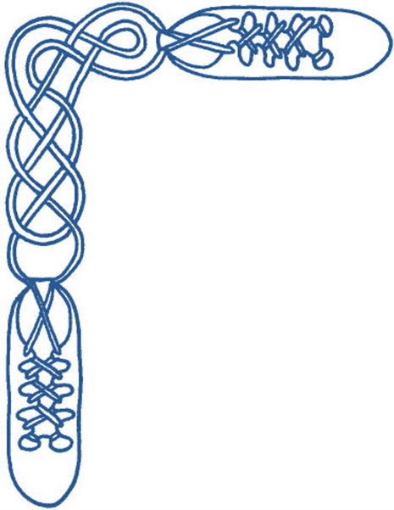
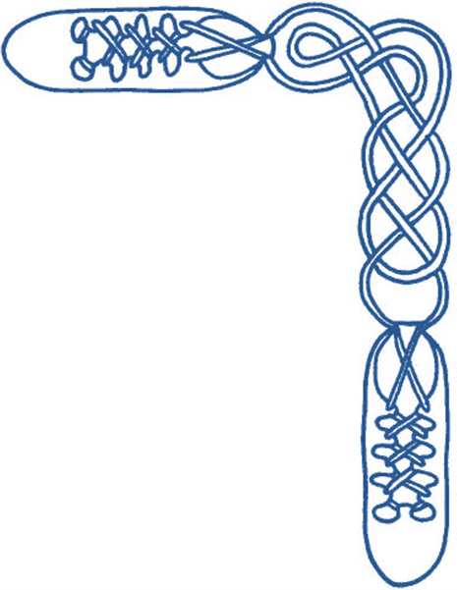

Harrow & District Caledonian Society

Wednesday 6th June 2012, 7:30 to 10:30 pm

St Alban’s Church Hall, Norwood Drive, Harrow, HA2 7PE

dancing to the music of Karl Sandeman

Admission £6 (£3 for juniors and non-dancers) including buffet supper

JUBILEE JIG, THE (J8x32) 3C (4C set) Scottish Country Dance Leaflet 19
1- 8 1M casts to 2nd place, sets to 3L, turns RH & dances back to 2nd place on own side
9-16 1L casts to 2nd place, sets to 3M, turns LH & dances back to 2nd place
17-24 1L with 2s & 1M with 3s dance RH across, 1s end in centre LH joined, 1s set in centre & dance out to 2nd place on opp sides
25-32 1M with 2s & 1L with 3s dance RH across, 1s end in centre LH joined, 1s set in centre & dance out to 2nd place on own sides

DUKE & DUCHESS OF EDINBURGH, THE (R8x40) 3C (4C set) Allie Anderson & Florence Lesslie
1- 8 1s+2s+3s Adv+Ret & turn partners 2H
9-16 1s cast, lead down between 3s, cast up behind 3s, lead up between 2s & cast back to 2nd place
17-24 1s dance RH across (Lady with 2s & Man with 3s), pass RSh & dance LH across with other couple to end facing 1st corners
25-32 1s turn 1st corner, partner, 2nd corner & partner to own sides 2nd place
33-40 2s+1s+3s circle 6H round & back

ROBERTSON RANT, THE (S80) Sq.Set Mrs Douglas Winchester, née Maidie Logie Robertson RSCDS Book 39
1- 8 All circle 8H round & back
9-16 All Ladies dance RH across ½ way & turn opposite Man LH, all Ladies dance ½ RH across & turn partner LH
17-24 1s+3s dance reel of 4 (Ladies start by passing LSh as Men set)
25-32 All set (HS) to corners, turn 2H twice
33-40 2s+4s dance reel of 4 with Ladies starting by passing LSh
41-48 All set (HS) to corners, turn 2H twice
49-56 All Ladies circle left to face partners (Ladies BtoB), set to & turn partners 2H
57-64 All Men circle right to face partners (Men BtoB), set to & turn partners 2H
65-72 All dance Grand Chain
73-80 All Allemande anticlockwise

DIAMOND JUBILEE (J4x32) 4C set Robert M Campbell RSCDS Book 31
1- 8 1s & 4s turn 1½ times RH & cast 1 place, 1M & 4M also 1L & 4L turn LH on sides to end 1s facing up & 4s down. 2(1)(4)3
9-16 All dance reels of 4 on sides (1s & 4s do not fully complete reel but turn right about into centre B to B facing crnr just passed). 2(4)(1)3
17-24 4s & 1s set to corners & change places RH, set & change back LH
25-32 1s+4s dance RH across while 2s & 3s set & cross RH, all set & cross RH back to places 2 4 1 3

TAM O' SHANTER (R8x48) 3C (4C set) Barry Priddey Tam O'Shanter Set
1- 8 1s set, cross RH, cast 1 place & turn LH to face 1st corners
9-16 1s dance full RSh reel of 4 with 1st corners & end with a LH turn to dance face out opposite sides between 2s+3s
17-24 1s dance Fig of 8 round 2nd+1st corners (LSh to 2nd corner to start) & turn LH to face 4th corner
25-32 1s dance full reel of 4 with 4th corners & turn LH to end Lady between 2s & Man between 3s
33-40 1s dance reel of 3 across giving LSh to 1st corner & end in 2nd place own sides
41-48 2s+1s+3s circle 6H round and back

SILVER TASSIE, THE (S8x32) 3C (4C set) John Drewry Bon Accord Book
1- 8 1s+2s+3s cross RH & set, cross back RH & set
9-16 1s & 3s dance Figs of 8 round 2s (3s casting)
17-24 1s followed by 2s+3s dance down, 1s followed by 2s+3s (who part to let 1s thru) dance back to top
25-32 1s+2s dance the Rondel

MIDSUMMER MADNESS (J8x32) 3C (4C set) John Drewry Bankhead Book 5
1- 8 1s+2s set & dance RH across ½ way, set & ½ turn partners
9-16 1s followed by 2s lead down below 3s cross & cast up behind 3s, lead up crossing & 1s cast to 2nd pl as 2s cross to 1st pl. 2 1 3
17-24 1s dance ½ reels of 3 across giving LSh to 1st corners & ½ reels of 3 on opposite sides
25-32 1s dance ½ reels of 3 across giving LSh to 3rd corners & ½ reels of 3 on own sides

CRAVEN TWELVESOME, THE (R4x32) Sq.Set Men+2 Ladies per side Derek Haynes Carnforth Collection 5
1- 8 All dance RSh reels of 3 with partners
9-16 All Men set, ½ RH across, dance out thru opposite Ladies & cast to right to middle of next side Ladies
17-24 Top & bottom trios (side Men with new partners) advance, Ladies ½ turn 2H opp Lady & retire with new partners, side trios repeat
25-32 All circle 12H round & back
Repeat from new places & with new partners

I N T E R V A L

DOMINO FIVE (R5x32) 5 person Sq.Set with 5th person in centre Derek Haynes, Carnforth Collection 4
1- 8 5+1+2 dance RH across, 5+3+4 dance LH across
9-16 5+1+3 dance RSh reel of 3 (5 & 1 pass RSh to start)
17-24 5+4+2 dance LSh reel of 3 (5 & 4pass LSh to start)
25-32 5 changes place with 1 (pass RSh), 1 change pl with 4, 4 change pl with 3, 3s change pl with 2
& 2 becomes new 5 (similar to Fisherman's Reel)

ANNIVERSARY REEL (R4x32) 4C set Sheila Muir RSCDS Book 36
1- 8 1s cross RH & cast 1 place, 1s dance ½ Fig of 8 round 2s
9-16 1L dances full reel of 3 with 2s while 1M dances ½ reel with 3s & ½ reel with 4s
17-24 1s dance LH across with 3s, 1s dance RH across (1L with 2s & 1M with 4s)
25-32 1s pass LSh to dance ½ reel of 4 with 3s, turn RH to opposite sides while 4s set advancing & 1s+4s dance RH across ½ way round to new places

MACDONALD OF THE ISLES (S3x32) 3C Set Derek Haynes Carnforth Collection of Scottish Country Dances 2
1- 8 2s dance full diagonal Reels of 4 with 1st corners, passing by the L Shoulder to face 2nd corners
9-16 2s dance full diagonal Reel of 4 with 2nd corners to end in original places
17-24 All dance 3 couple Snowball Grand Chain to end 3 (2) 1:
`1s cross RH & change places LH on side with 2s
`1s change places RH with 3s while 2s cross over RH
`1s cross LH while 2s & 3s change places LH. 3 (2) 1
25-32 3s+2s dance ½ R & L, 3s dance ½ Fig of 8 round end couples (3M up & 3L down) to end in 2nd places

SHIFTIN' BOBBINS (R8x32) 3C (4C set) Roy Clowes Ormskirk Scottish Dances Book 6
1- 8 1s cross RH to double triangle position with 2s+3s & set, 1s cast up to top & dance down until they are between 2s & 3s
9-16 1L dances RH across with 2M+3M while 1M dances LH across with 2L+3L, 1s followed by 2s+3s dance down centre
17-24 3s followed by 2s+1s dance up & 3s+2s cast to places, 1L dances LH across with 2M+3M while 1M dances RH across with 2L+3L
25-32 1s dance up to top & cast down to 2nd place opposite side, 1s dance ½ Fig of 8 around 2s to end in 2nd place on own sides

MINISTER ON THE LOCH, THE (S3x32) 3C set Roy Goldring 24 Graded & Social Dances
1- 8 1s+2s dance All Round Poussette
9-16 1s dance down for 2 steps, turn 2H, dance up to top & turn 2H
17-24 1s+3s dance double Fig of 8 round 2s with 1s casting to start
25-32 1M+2M turn LH 1½ times while 1L+2L turn RH 1½ times, 1M+3M turn RH 1½ times while 1L+3L turn LH 1½ times

IAN POWRIE'S FAREWELL TO AUCHTERARDER (J128) Sq.Set Bill Hamilton, Ian Powrie’s Farewell to Auchterarder
1- 8 All circle 8H round to the left & back
9-16 Ladies dance in front of partner & behind next Man, into RH across
17-24 Ladies dance in front of Man opp own partner & behind next Man, into RH across & back to place
25-32 All Promenade clockwise
33-40 1s & 3s dance cl'wise behind next couple, Men dance past couple as Ladies dance in between couple & both turn R to face couple,
all set & turn RH
41-48 All dance parallel reels of 4
49-56 1s & 3s dance a full Fig of 8 round the standing 2s/4s
57-64 1s & 3s dance LH across, 1s & 3s dance back to places (Men round & Ladies through the standing 2s & 4s)
65-96 2s & 4s repeat 33-64
97-104 All Promenade anticlockwise
105-112 Men dance in front of ptnr & behind next Lady, into LH across,
113-120 Men dance in front of Lady opp own partner & behind next L into LH across & back to pl
121-128 All circle 8H round to the right & back (popular variation - 8 hands all the way round to right)

MONTGOMERIES' RANT, THE (R8x32) 3C (4C set) Castle Menzies RSCDS Book 10
1- 8 1s cross RH & cast down to 2nd place, cross LH & 1L casts up while 1M casts down
9-16 1s dance reels of 3 across, 1L with 2s & 1M with 3s
17-24 1s with NHJ (Lady on Man’s left) set to 2L & turn inwards to set to 3M, set to 3L & turn inward & set to 2M
25-32 2s+1s+3s dance reels of 3 on opposite sides 1s giving RSh to 2nd corner, 1s cross RH to 2nd place own sides



