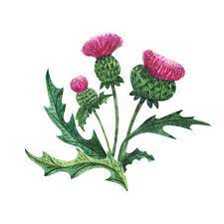
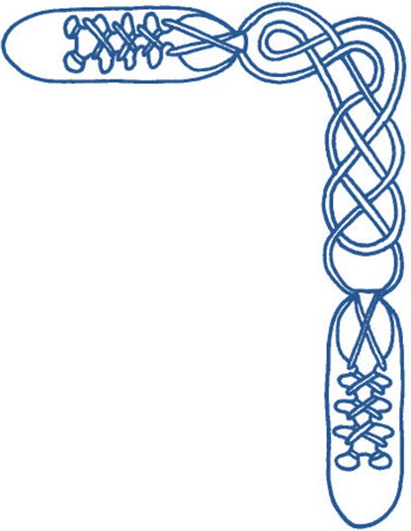
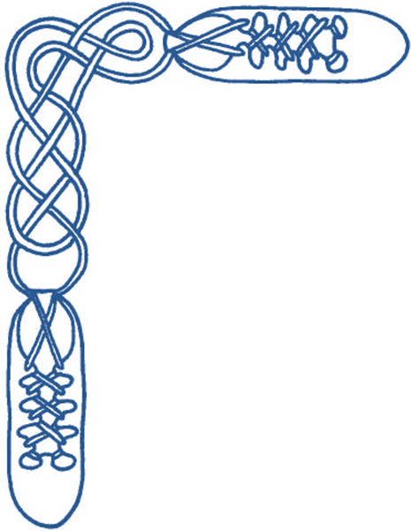

Harrow & District Caledonian Society

Summer Dance

Wednesday 29th May 2024

from 7:30 until 10:15 pm

St Alban’s Church Hall, Norwood Drive, Harrow, HA2 7PE

dancing to the music of Chris Oxtoby

Admission £10 (£5 for juniors and non-dancers) – please bring a contribution to the refreshment table

SHETLAND SHEPHERDESS, THE (J8x32) 3C (4C set) www.youtube.com/watch?v=9YdiXJGvgqY Ron Wallace RSCDS Graded 3
1- 8 1s dance down between 2s, cast back to places. 1s dance ½ Fig. 8 round 2s
9-16 1s+2s+3s dance mirror (reflection) reels of 3 on sides (1s cross to 2nd place own sides to begin, 2s out & up, 3s in & up).
2s finish facing out
17-20 1s+2s change places on sides (Men RH, Ladies LH), 1s+3s turn on sides (Men LH, Ladies RH)
1s ending in middle facing up, 3s in original places
21-24 1s dance up to top and cast to 2nd place
25-32 2s+1s+3s Adv+Ret, all clap end bar 28. 2s+1s+3s turn partners RH once round

VISITS TO GLAMIS CASTLE (R8x40) 3C (4C set) Mervyn Short 12 SCDs 1985
1– 8 1s+2s ½ R&L, 1s+3s ½ R&L (2) (3) 1
9– 16 1s lead up between 2s, cross and cast to 2nd place opp sides (3s step down),
1s dance ½ Fig of 8 (L round 3s. M round 2s) to end back to back in centre facing own side (2) 1 (3)
17–24 Double Triangles, 1s end facing 3rd corners
25–32 ½ Reel of 4 on 1st diagonal, pass RSh, ½ Reel of 4 on 2nd diagonal 3 1 2
33–40 All chase clockwise half way to (2)(1)(3), all set and cross RH 2 1 3

KILKENNY CASTLE (S8x32) 3C (4C set) www.youtube.com/watch?v=3mbqi10L4Cc&t=16s Bill Forbes Craigievar Book 2
1- 8 1s+2s set, 1s cross RH & cast 1 place, 1s dance in to meet partner & face down, 1s turn 3s with nearer hand to face up
9-16 1s dance reflection reels of 3 on sides (1s dancing in & up between 2s to start)
17-24 1s petronella turn to middle as 2L+3L & 2M+3M change pl RH, set in lines across,
1s petronella turn to sides as 2s+3s cross RH & set on sides
25-32 1s dance Diag R&L (1M crossing down & 1L crossing up)

LES REMPARTS DE SÉVILLE (J8x32) 3C (4C set) https://youtu.be/aaezP049s9k?t=20s Aliénor Latour RSCDS Book 50
1- 8 1s set, cast (2s step up bars 3-4), 1s dance ½ Figs 8, 1L round 2s, 1M round 3s
9-16 1s turn LH to face 1st corners (2 bars) and dance set to corners and partner ('Hello-Goodbye') (6 bars)
to end 1M between 2s facing down, 1L between 3s facing up
17-24 2s+1s+3s set and link, all set, all cross RH
25-32 2s+1s+3s circle 6H round and back

TRIP TO EDINBURGH, A (R4x32) 4C Sq. Set https://youtu.be/GVDUzxN8_iw Andrew Nolan Edinburgh 90th Anniv
1- 8 1s+3s Adv+Ret. 1M+3L & 1L+3M change places RH turning inwards to face partners. 1s+3s set
9-16 2s+4s repeat bars 1-8
17-24 1s+3s set.
1L+3L changes places RH, dance clockwise ½ round outside of set to places
while 1M+3M cast, dance clockwise ½ way round outside of set, change place RH with each other to finish on Right of partner
25-32 All couples set to partners, turn 2H ½ way (skip change). All circle 8H round ¾ to Left

GOLDEN HILL FORT (S3x40) 3C Triangular set Judy Valvona for IW Platinum Ann.
1-8 All dance Grand Chain
9-16 All set & turn partner RH, all set & turn corner LH, ladies finish facing out
17-24 All dance Schiehallion Reels (8 bars, ie move on TWO places, maintaining the triangular shape), ladies finish facing out
25-36 Men’s Chain for 3 couples
While ladies dance into their partner's position
men give Left Hands Across and travel two places anticlockwise.
Each man turns the "new" partner in that position (RH, as in men's chain).
Repeat the same pattern twice more to return to original partner (still in the progressed place reached in the Schiehallion reel).
37-40 3s (in top place) dance into centre, part and dance 3M out between 1s, 3L out between 2s and cast back to place.

ROYAL YACHT BRITANNIA, THE (R8x40) 3C (4C set) www.youtube.com/watch?v=hCh_aHEu26E&t=6s John Drewry RSCDS Book 43
1- 8 1s set, dance down to 2nd place and out own side, cast round to left and into middle (2nd place) LSh to LSh (on opposite sides)
9-16 1s dance RH across (Lady with 2M+3M and Man with 2L+3L) and LH across with 2s+3s on own sides
1s end passing LSh to face 1st corners
17-24 1s set to 1st corners, 1s dance RSh round each other to face 2nd corners, set and dance round each other
to 2nd place own side facing out
25-32 2s+1s+3s dance reels of 3 on own sides (1s giving RSh to person on their right)
33-40 2s+1s+3s circle 6H round and back

I N T E R V A L

TOAST TO THE MOUSIES (R8x32) 3C (4C set) www.youtube.com/watch?v=uEeiOzzBNtc&t=18s Sara Gratiot /RSCDS Book 53
1- 8 1s dance in and cast 1 place (2s step up), dance down between 3s and cast up to 2nd place
9-16 2s+1L also 1M+3s dance RH across and 1s pass RSh to dance LH across with other couple,
1s end back to back in the middle (1M facing up, 1L down) facing 2s/3s (2s facing down, 3s up nearer hands joined)
17-24 All set, 2s and 3s make arches, dance down/up to meet as 1s dance under arches.
Finish 1M in 1st pl, 1L in 3rd pl (facing down/up) and 2s & 3s back to back in middle nearer hands joined (2s facing up, 3s down)
All set, 2s and 3s making arches dance to ends and cast into reel
while 1s dance under arch passing LSh and finish between end couple facing 1st corner
25-32 2s+1L also 1M+3s dance LSh reels across (2s+3s make loops into the reel) to end 213. All set

BALMORAL STRATHSPEY (S4x32) 4C set www.youtube.com/watch?v=NdnKwxCXssE&t=18s John A Charles RSCDS Book 22
1- 8 1s+2s & 3s+4s dance R&L
9-16 1s+2s & 3s+4s set & dance RH across ½ way, set & cross RH to own sides. 2 1 4 3
17-24 All dance reel of 4 on own sides, 2s end in 1st place on sides, Bar 24 1s+4s+3s all dance into centre towards partner ready for ...
25-32 1s+4s+3s (bottom 3 couples) dance Allemande (2s in top place stand)

CASTLE OF MEY, THE (R8x32) 3C (4C set) www.youtube.com/watch?v=t29gjE7RWwU&t=7m46s John Walton QE Diamond Jubilee Dances
1– 8 1s dance Inveran reels with 2s+3s
9–16 1s+2s dance double Figs of 8 (1s start by crossing down)
17-24 1s lead down the middle & up, 1s end in middle of the set
25-32 1s+2s dance Poussette

ELEPHANT'S STAMPEDE, THE (J4x48) Sq.Set www.youtube.com/watch?v=f9ZOMKBprYc&t=5s L MacDonald & G Mackintosh Aurora 10th Anniv Bk
1- 8 All circle 8H round and back
9-16 1s+3s advance NHJ and with free hand join with 2s and 4s, retire into longwise set across the dance;
all dance ½ parallel RSh reels of 4 across
17-24 All dance ½ R&L at each end of set (across to start);
end couples and middle couples turn RH 1½ times to form Sq.Set
25-32 All Ladies petronella turn to next Ladies' place to right and set,
repeat to meet partner (all have progressed 1 place to right), Ladies face out
33-48 All dance full Schiehallion Reel. 2 3 4 1

WATER OF LEITH, THE (S4x32) 4C set www.youtube.com/watch?v=iDpctXSObCo&t=8s John Wilkinson Edinburgh 90th Anniv
1- 8 1s+3s set. 1L dances down, casts up round 2M into middle facing down as 1M dances across, casts round 2L into middle facing up while 3s dance same round 4s. 1s+3s change places RH with partner into line of 4 in middle (M face down, L face up)
9-16 1s+3s dance reel of 4 in middle
17-20 1s+2s also 3s+4s dance RH across
21-24 1M followed by 1L casts round 2L to 2nd place own sides as 3M followed by 3L casts round 4L to 4th place (2s+4s step up 23-24)
25-32 1s+4s (middle couples) dance Espagnole:
25-26 1s+4s cross (Ladies lead across RH passing between Men) with Ladies changing places RH
27-28 1s+4s cross back (Men lead across RH between Ladies) with Men changing places RH
29-32 4s turn RH as 1s turn LH

HOT PUNCH (J4x32) 4C set John W Mitchell Whetherly Dance Sheet 21
2 chords – 2nd chord 3s and 4s cross to opposite side
1- 8 All set, 1s & 4s cast in 1 place (2s and 3s step up/down);
1s & 4s cross RH and cast up/down into lines across (1s between 2s, 4s between 3s)
9-16 All advance and retire up/down set; 1s+4s dance ½ R&L (4s now between 2s, 1s between 3s, Man facing Lady)
17-24 4s+2s also 1s+3s dance reels of 4 across. At end 4s & 1s start turning partner LH
25-32 4s & 1s continue turning LH moving up/down (4s to top on opp sides facing out, 1s to 4th pl own sides facing out);
4s & 1s cast to 2nd/3rd place and dance ½ Fig of 8 up/down round 2s/3s. 2 4(1)(3)

GLASTONBURY TOR (R8x32) 3C (4C set) www.youtube.com/watch?v=N4dtvlD7h08 Duncan Brown RSCDS Book 47
1- 8 1s+2s set & dance RH across ½ way, 1s+3s set & dance LH across ½ way
9-16 1s set & cross RH, 1s cast up 1 place & turn LH turn to face 1st corners
17-24 1s dance ½ reel of 4 with 1st corners & pass left to face 2nd corners, 1s dance ½ reel of 4 with 2nd corners & curve right
to end 1M between 3s & 1L between 2s
25-32 1M+3s also 1L +2s Set+Link for 3 once, 1s turn RH 1½ times to 2nd place as 2s & 3s dance clockwise ½ way to places 2 1 3

Classes continue 12th June to 17th July (AGM so no class 5th June)

Summer activities include Lunch, River trip, Picnic, Bowls

Classes resume after summer break on 11th September

– All welcome –

