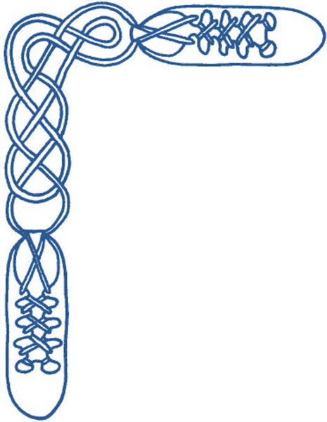
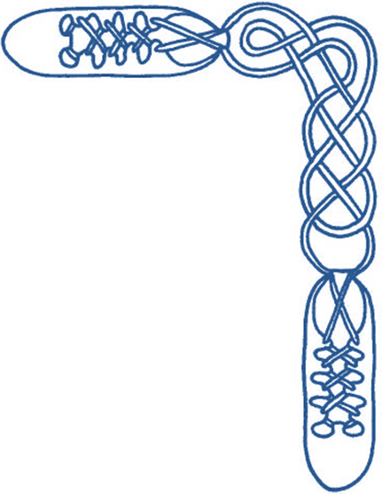

Harrow & District Caledonian Society

Wednesday 31st May 2017
7:30 to 10:30 pm

St Alban’s Church Hall, Norwood Drive, Harrow, HA2 7PE

dancing to recorded music

Admission £3 (£1.50 for juniors and non-dancers) including buffet supper

(NB there is another dance of same name by Hugh Foss)
CUTTY SARK (J8x32) 3C (4C set) www.youtube.com/watch?v=Kb0ItNczvxc&t=8 unknown deviser RSCDS Book 40
1- 8 1s cast down own sides & cast back to 2nd place
9-16 2s+1s dance RH across & LH back
17-24 1s turn RH to face 1st corners, turn 1st corner LH, turn 2nd corner RH & cross LH to 2nd places own sides
25-32 2s+1s+3s Adv+Ret & turn RH

BLOOMS OF BON ACCORD (R4x32) 4C set 3s & 4s on opp sides www.youtube.com/watch?v=27em4ertfPQ&t=23 John Drewry Deeside Book 2
1- 8 All set & 1s+2s also 3s+4s dance RH across once round, 1s & 4s cast in 1 place to 2 1 (4)(3)
9-16 1s & 4s cross RH & cast to ends of set to meet partners in prom hold & dance into centre of dance
1s+4s dance round passing RSh & to end 1s in the middle on Men’s side facing up & 4s in the middle on Ladies side facing down
17-24 All (1s & 4s in prom hold) dance reels of 3 on sides
25-32 4s+1s dance RH across in centre once round to end 4s facing up & 1s facing down
4s & 1s lead out of ends crossing & cast in 1 place to end 2 4 (1)(3)

LEA RIG,THE (S8x32) 2C (4C set) www.youtube.com/watch?v=tE26QSnQVNk&t=32 unknown deviser RSCDS Book 21
1-16 1s+2s (2s step up & join in on bar 3 by setting then follow 1s) dance full Petronella back to places
with 2s turning to place on bars 15-16
17-24 1s lead down centre of set & back to top
25-32 1s+2s dance RH across once round & ½ Diamond Poussette to change places

GLOBE INN, THE (J8x32) 3C (4C set) Jackie Johnstone Loreburn Dances Book 4
1- 4 1s & 3s ¾ turn RH & set to partner
5-16 1s+2s+3s Dance to each 'Corner' & Set (diamond shaped square with corners on sides & ends) :
2s set while 1s & 3s change places with partners passing RSh & 1L+3M pass RSh face side 'corners',
1M & 3L set while 1L+2M also 3M+2L change places passing RSh & 2s pass RSh to face end 'corners',
1L & 3M set while 1M+2L also 2M+3L change places passing RSh & 1L+3M pass RSh to face side corners (partners),
1s & 3s change places with partners passing RSh & 1L+3M pass RSh to face end ' corners',
1M & 3L set on sides while 2L+3M also 1L+2M change places passing RSh & 2s pass RSh to face side 'corners',
2L+1M also 2M+3L change places passing RSh & 1M+3L pass RSh to face partners (2s in places opposite sides & 3s+1s in centre)
17-24 1s+3s dance ½ reel of 4 up/down centre, 1s+2s+3s set & turn partners LH to end 1s+2s in centre for Poussette & 3s in own pl
25-32 1s+2s dance Poussette. 2 1 3

CRAVEN TWELVESOME, THE (R4x32) Sq.Set Trios: M+2Ls per side www.youtube.com/watch?v=TvGKVCnzrkY&t=2m40s Derek Haynes Carnforth Coll 5
1- 8 All dance RSh reels of 3 with partners
9-16 All Men set, ½ RH across, dance out thru opposite Ladies & cast to right to middle of next side Ladies
17-24 Top & bottom trios (side Men with new partners) advance, Ladies ½ turn 2H opposite Lady & retire with new partners,
side trios repeat
25-32 All circle 12H round & back
Repeat from new places & with new partners

BURNS BICENTENARY STRATHSPEY (S4x32) 4C set 3s & 4s on opp sides www.youtube.com/watch?v=J1ptbhD0jnM&t=12 John Drewry Bankhead Bk 6
1- 8 1s+2s also 3s+4s circle 4H to left & Set+Link on sides
9-16 All dance RSh reel of 4 on sides
17-24 1M+4L & 4M+1L dance Ladies Chain (end facing in prom hold)
25-32 1M+4L & 4M+1L Promenade across (Men passing LSh),
4s dance up between 2s & cast to 2nd places while 1s dance down & cast to 3rd places

SETON'S CEILIDH BAND (J4x64) 4C set www.youtube.com/watch?v=lzrLNS9XNIM A Bruce Fordyce Morison's Bush Collection
1- 8 1s cross RH & cast 1 place, dance down between 3s & cast behind 4s
9-16 1s dance reflection reels of 3 on opposite sides beginning by dancing up between 4s
17-24 1s cross RH & cast up 1 place, dance up between 3s & cast up behind 2s
25-32 1s dance reels of 3 on own sides beginning by dancing down between 2s
33-40 1s cross RH & cast down 1 place to give RH to partner & LH to 1st corners, Bal-in-Line & turn partner RH to give LH to 2nd corners
41-48 Balance-in-Line & 1s dance out & cast down behind 3s, lead up to top crossing to 1st place own sides
49-60 1L+2L & 1M+2M change places RH on sides & 2s+1s cross over LH, repeat with 3s & 4s until reaching the bottom of the set
61-64 All turn RH 1½ times

Wednesday 31st May 2017 7:30 to 10:30 pm

I N T E R V A L

SHIFTIN' BOBBINS (R8x32) 3C (4C set) www.youtube.com/watch?v=5sQyMClZNjU Roy Clowes Ormskirk Scottish Dances Book 6
1- 8 1s cross RH to double triangle position with 2s+3s & set, 1s cast up to top & dance down until they are between 2s & 3s
9-16 1L dances RH across with 2M+3M while 1M dances LH across with 2L+3L, 1s followed by 2s+3s dance down centre
17-24 3s followed by 2s+1s dance up & 3s+2s cast to places, 1L dances LH across with 2M+3M while 1M dances RH across with 2L+3L
25-32 1s dance up to top & cast down to 2nd place opposite side, 1s dance ½ Fig of 8 around 2s to end in 2nd place on own sides

TAM O’ SHANTER (R8x48) 4C set www.youtube.com/watch?v=jO1m6dlixoE&t=3m39s Barry Priddey Tam o’ Shanter Set
1- 8 1s set, cross RH, cast 1 place & turn LH to face 1st corners
9-16 1s dance RSh reel of 4 with 1st corners & end with a LH turn to dance face out opposite sides between 2s+3s
17-24 1s dance Fig of 8 on sides round 2nd+1st corners (LSh to 2nd corner to start) & turn LH to face 4th corner
25-32 1s dance reel of 4 with 4th corners & turn LH to end Lady between 2s & Man between 3s
33-40 1s dance reel of 3 across giving LSh

DREAM CATCHER, THE (S96) Sq.Set www.youtube.com/watch?v=WWW1YaHN8BQ&t=3m21s Eileen Orr RSCDS Book 45
1- 8 All circle 8H round & back
9-16 1s+3s dance the Swirl: -
Turn partner RH into Allemande hold & dance LSh round other couple ½ way,
dance LH across ¾ way & swirl to face side couples (BtoB with ptnr & Lady facing Man)
17-24 All dance reels of 4 across
25-32 All set & dancing couples dance out between side couples, cross & cast to change places RH with partner back into places
33-40 All set & advance with partners, retire diagonally with corners & set
41-48 1L+4M dance R&L with 3L+2M (on diagonal)
49-56 1M+2L dance R&L with 3M+4L (other diagonal)
57-64 All set with corners, Adv+Ret with partners & set
65-88 2s & 4s repeat bars 9-32
89-96 All circle 8H round & back

FALLS OF ROGIE, THE (R8x32) 3C (4C set) www.youtube.com/watch?v=tF7_lLhG9Mo Jean Attwood Alexander Book 1
1- 8 1s cross RH & cast 1 place, 1s cross RH & cast 1 place (Man up Lady down)
9-16 1s dance ½ reels of 3 across (1M with 2s & 1L with 3s), set in lines across & change places RH with opposite person
17-24 2s+1s+3s chase clockwise ½ way,
1s dance in & turn RH to face 1st corner positions as 2s & 3s continue to chase on to places (as bar 16)
25-32 1s dance ½ reel of 4 with 1st corners, passing RSh dance ½ reel with 2nd corners & cross passing RSh to 2nd place own sides

FLOWER O' THE QUERN 1, THE (S4x32) 4C set 3s & 4s on opp sides www.youtube.com/watch?v=kGpiyWbBXbg John Drewry Canadian Book
1- 8 1s+2s & 3s+4s circle 4H round to left to end in middle,
1s+2s also 3s+4s set facing, 1s+4s cast in 1 pl & change pl LH on sides with other dancer
9-16 1s+4s dance ½ Figs of 8 round end couples, change places LH again on sides,
dance ½ Fig of 8 round other end couple & change pl again LH
17-24 All dance reels of 4 on sides. 2 4 1 3
25-32 2s+4s also 1s+3s set facing on sides, 1s & 4s turn end couples (dancing between ends) & dance ½ Figs of 8 round end couples
to end 2 4 1 3

MIDSUMMER MADNESS (J8x32) 3C (4C set) John Drewry Bankhead Book 5
1- 8 1s+2s set & dance RH across ½ way, set & ½ turn partners
9-16 1s followed by 2s lead down below 3s cross & cast up behind 3s,
lead up crossing & 1s cast to 2nd place as 2s cross to 1st place. 2 1 3
17-24 1s dance ½ reels of 3 across giving LSh to 1st corners & ½ reels of 3 on opposite sides
25-32 1s dance ½ reels of 3 across giving LSh to 3rd corners & ½ reels of 3 on own sides

MRS MACPHERSON OF INVERAN (R8x32) 3C (4C set) www.youtube.com/watch?v=Muq5sjFYXJA John Drewry Bon Accord Book
1- 8 1s dance Inveran Reels with 2s+3s
9-16 1s turn RH 1½ times moving down to 2nd places (opposite sides), 1s cast up behind 2s & cross down to 2nd place own side
17-24 2s+1s+3s dance Grand Chain
25-32 2s+1s+3s circle 6H round & back

Classes continue 7th June to 12th July (AGM so no class 14th June)

Classes resume after summer break on Wednesday 13th September

Our Day school will be on Saturday 23rd September

– All welcome –



